Title: Simple Movie Booking cap Stone Project
By
Tanguturi Venkata Lakshmi Ajay
Under Guidance from
Akash Kale

A Report Generated for Capstone Project under Mandatory VILT Session for UST Pre On-boarding Training.

Batch: Wave 1 Batch 1

Description:
Simple Movie Booking is a REST-based application that allows users to manage movies, schedule shows, book tickets, and cancel bookings. It ensures proper seat availability by reducing seats when tickets are booked and restoring them when bookings are cancelled, with all data handled through a structured backend using Spring Boot and MySQL.

Objective:
Design and Develop a RESTFUL backend application using Spring Boot, Spring Data JPA, MYSQL for a Simple Online Booking System
Technology Stack Used:
- Spring Boot
- MYSQL Driver
- Spring Data JPA
- Spring REST Docs

Procedure:
- Using Spring Initalizr Create a Zip file with all the necessary Dependencies for achieving the project
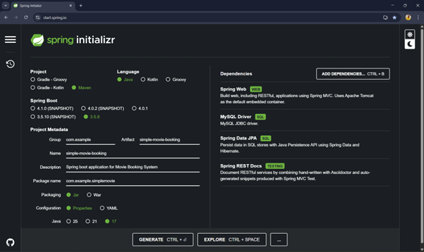
- Import this Zip file using Eclipse IDE so that all the pom.xml files and maven projects are imported.

- Use application.properties file to connect database from your local database machine
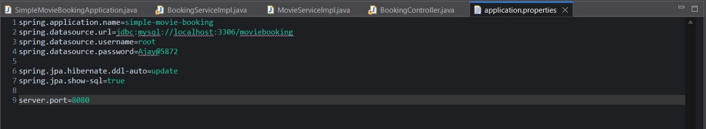

- Create Entity Layers for the Movie booking system for database tables and those are a. Movie b. Show c. Booking
With all the columns given for creating the database.
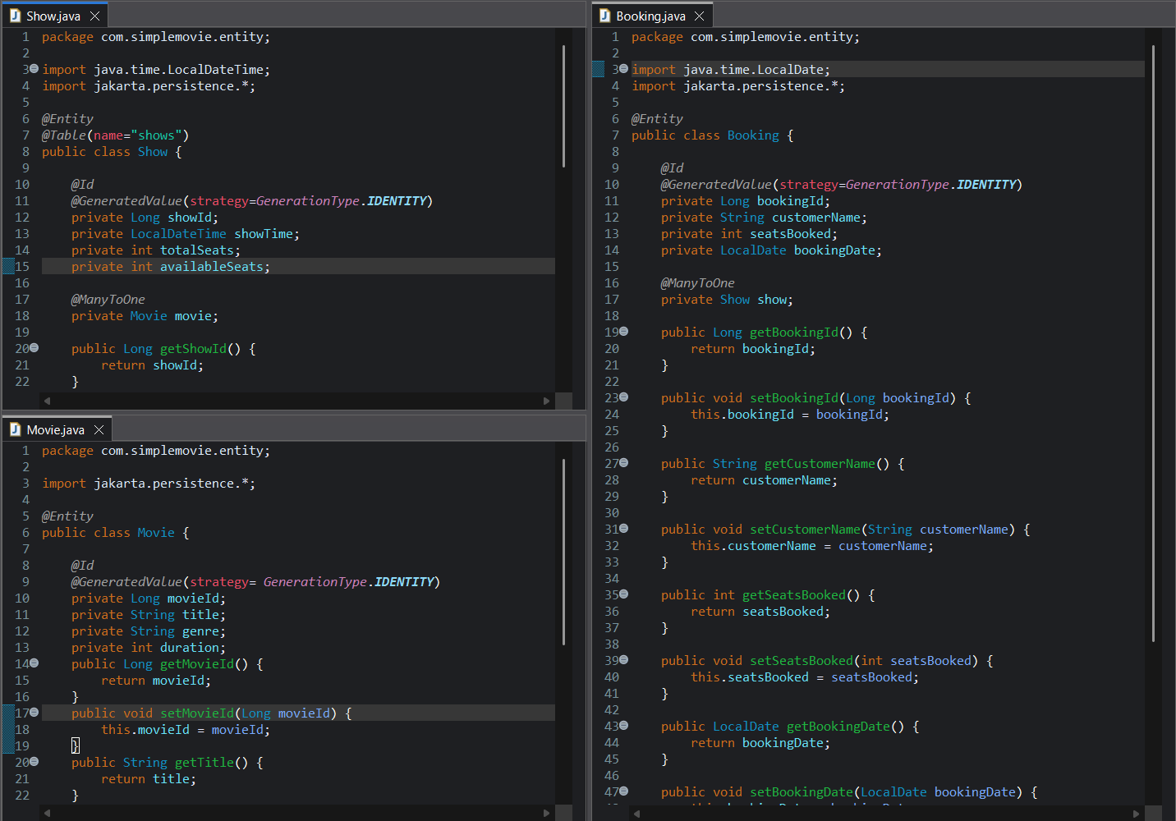
- Create Repository Layer for the system to manage database where it is internally connected to the database to add, delete, update data’s while we give externally.
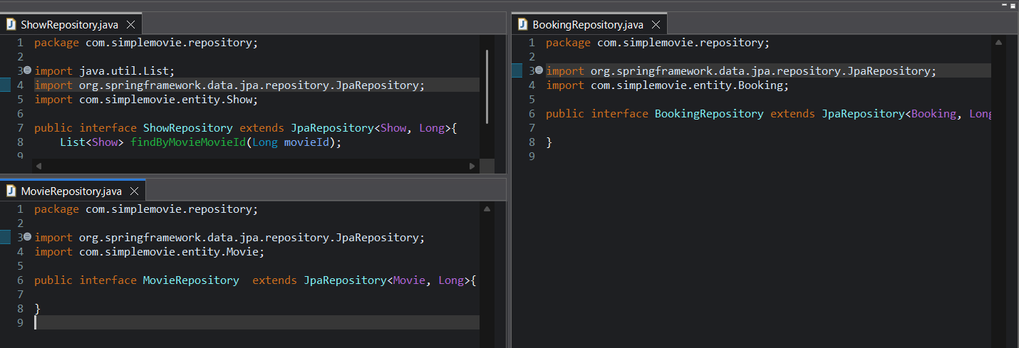

- Now after this Repository layer we are supposed to create service layer because that is the place we have to write all the logics to book tickets , cancel booking and update bookings and all that . This is the place where all the displaying of data from the database will be operated. This is also the place for connecting the repository layer using interfaces .
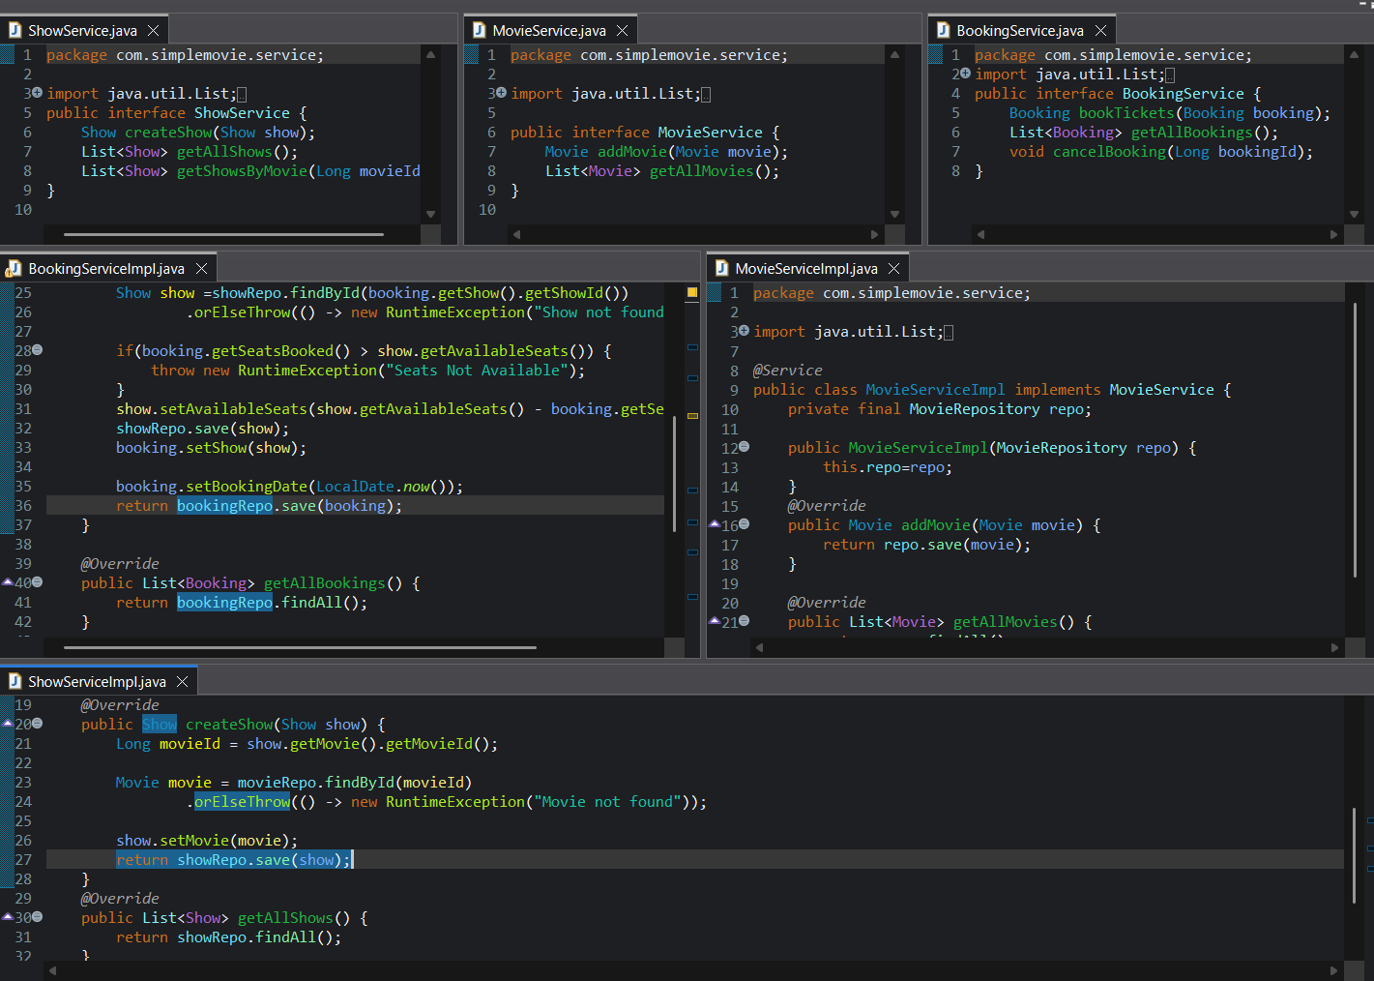

- After the service layer we create the controller layer to control all the access of the booking system .
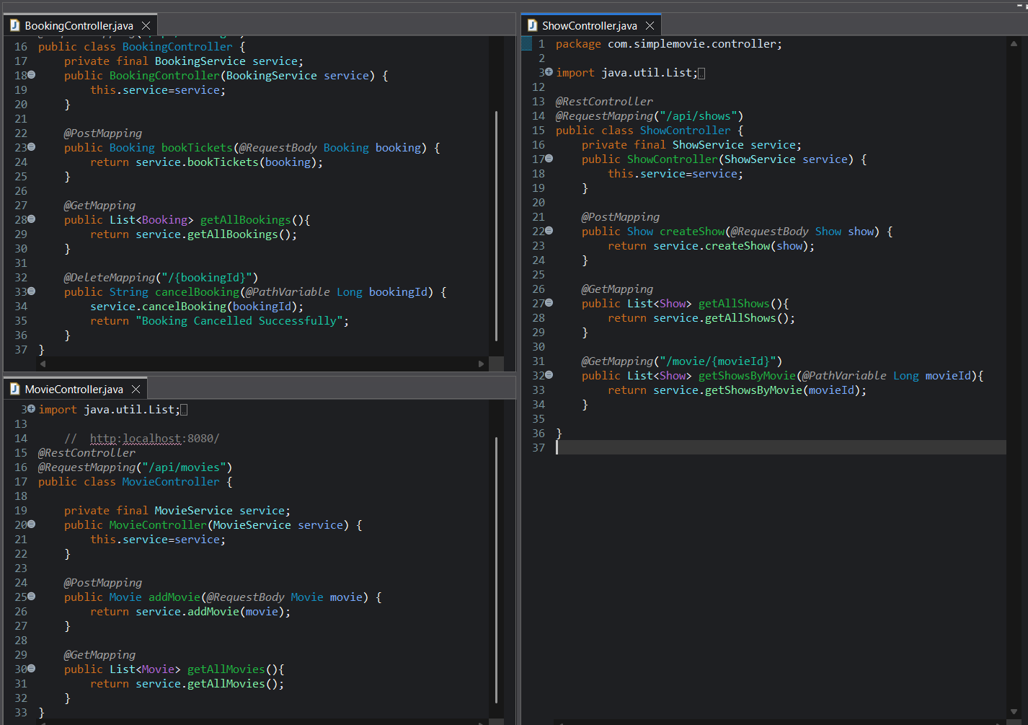
- Now after implementing all the class files now we use main file so that the spring boot application will start and connect to our database and by using postman we will achieve all the required results from postman.
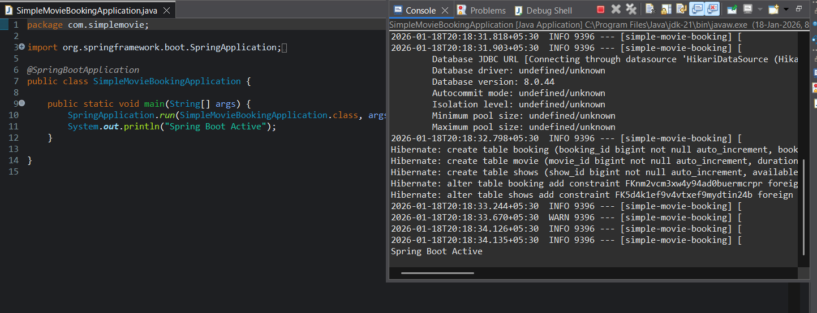
Results:
- API 1: Add Movie
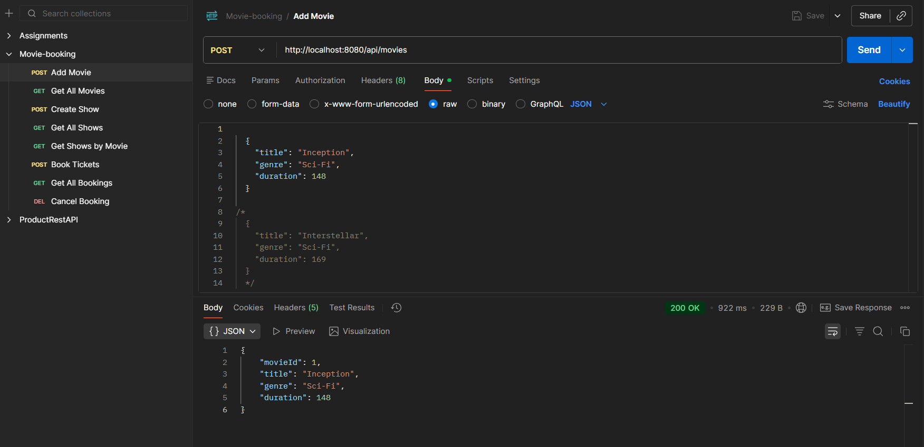
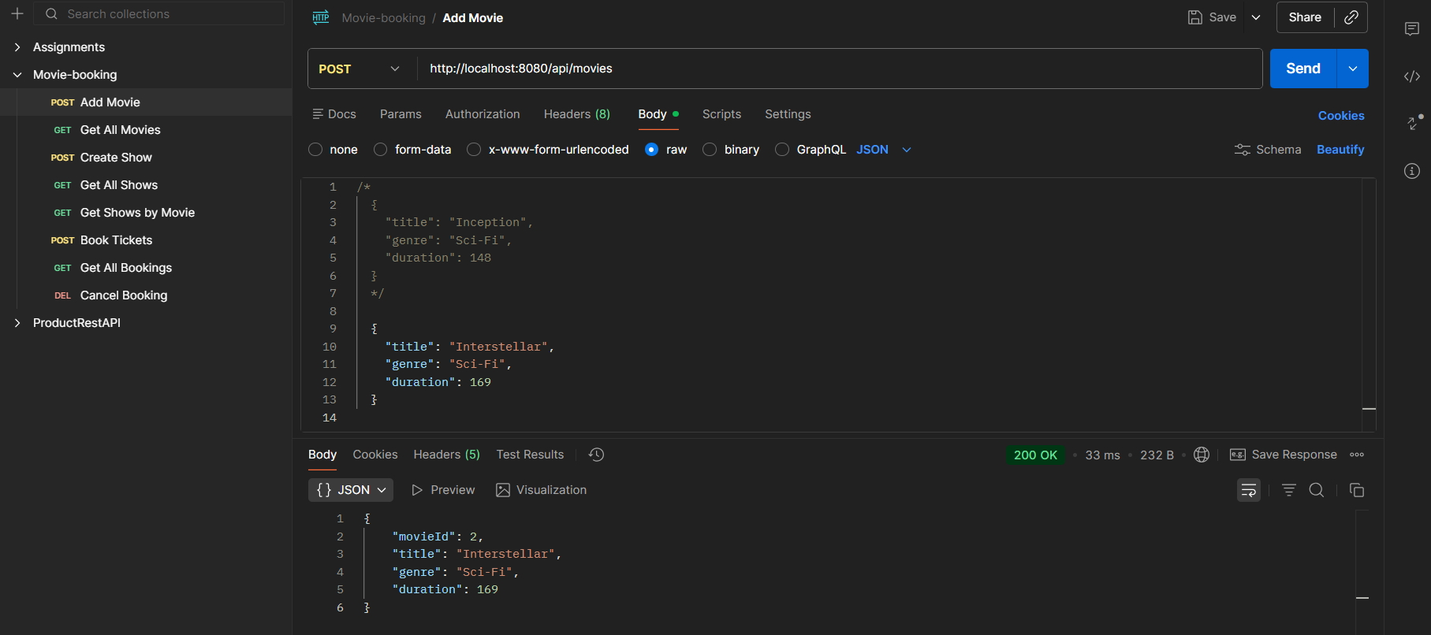
- API 2: Get All Movies
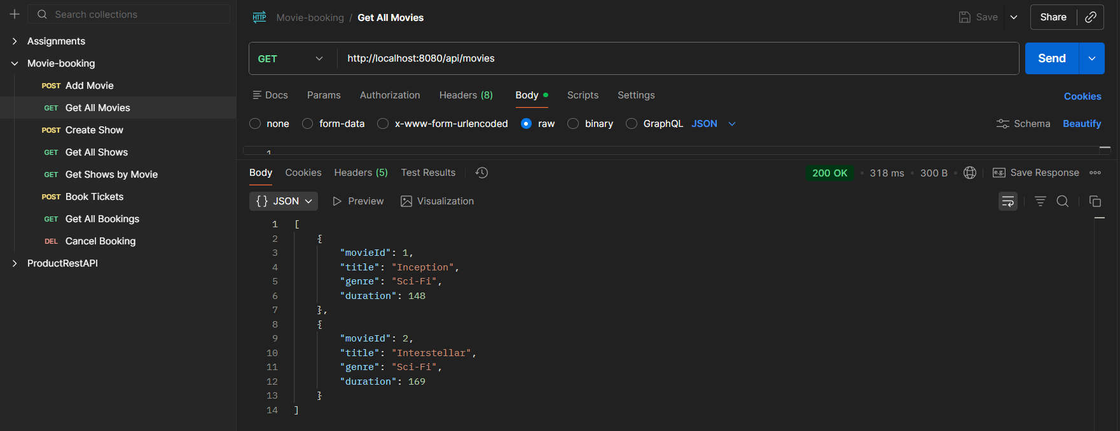
- API 3: Create Show
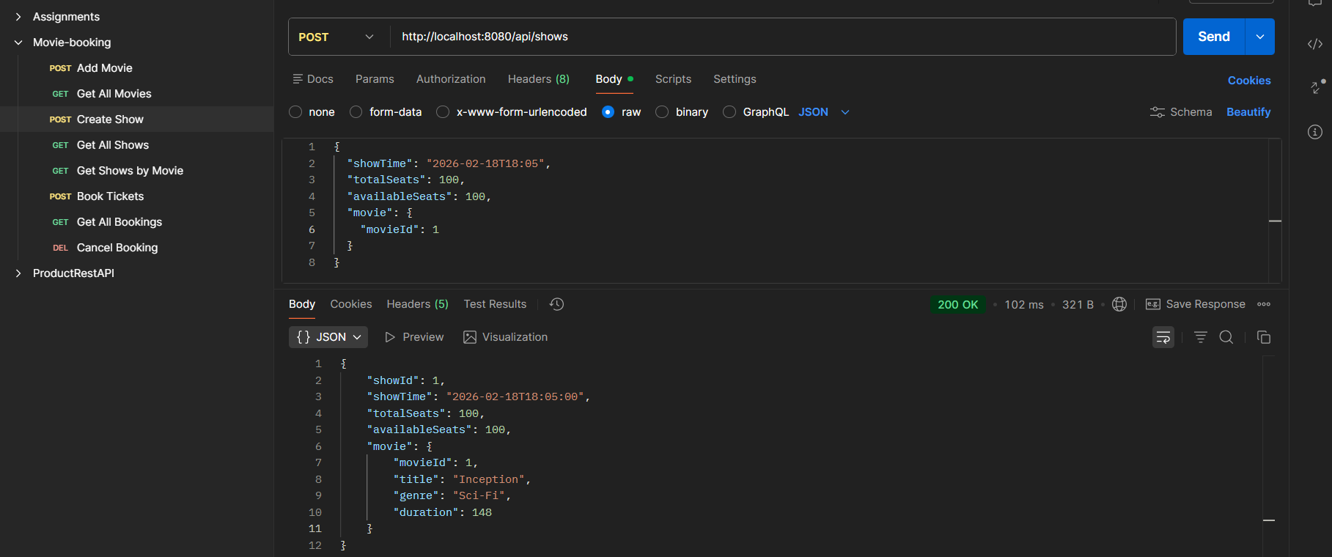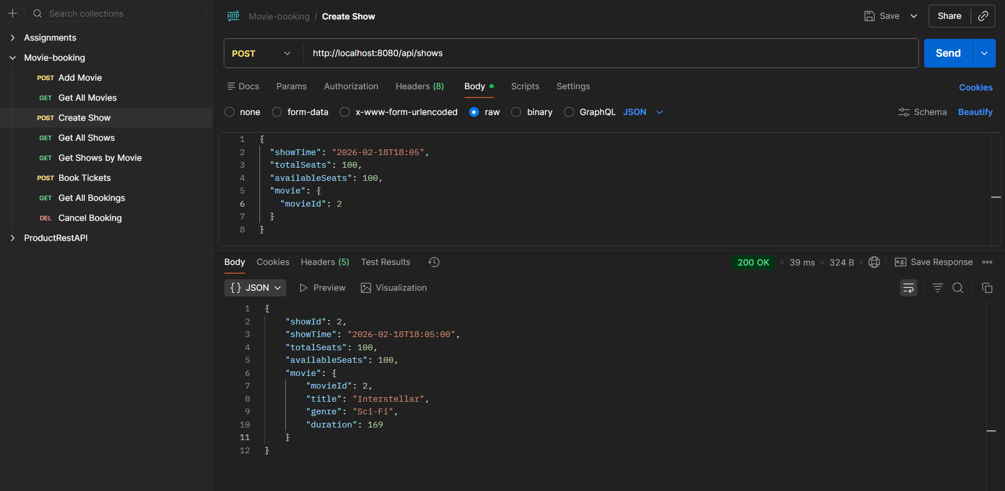

- API 4: Get All Shows
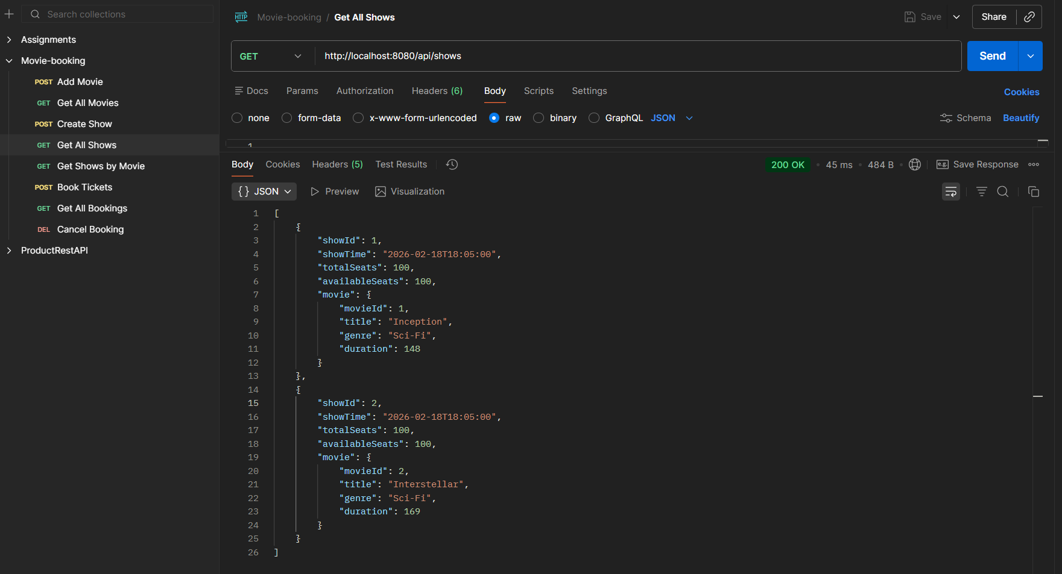
- API 5: Get Shows by Movie
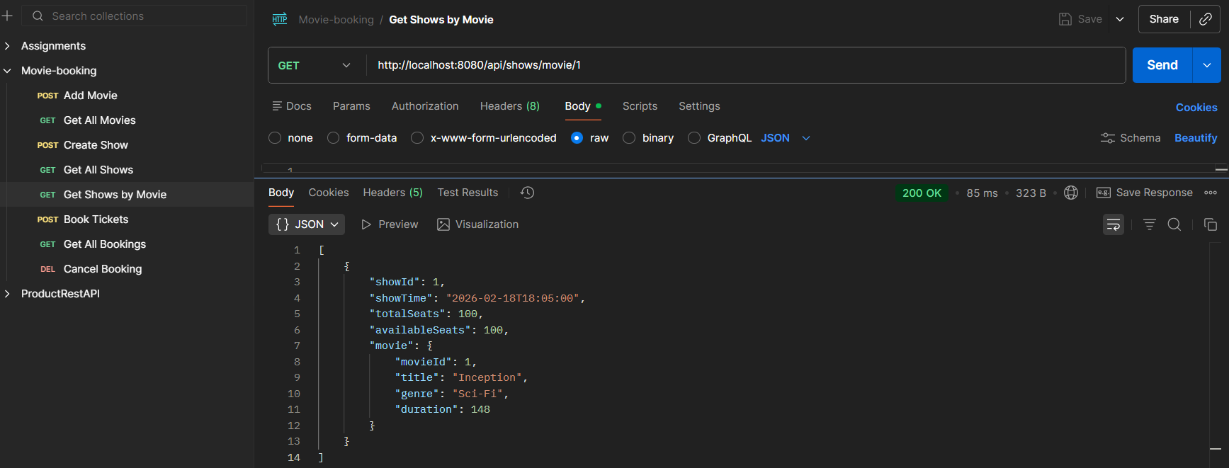
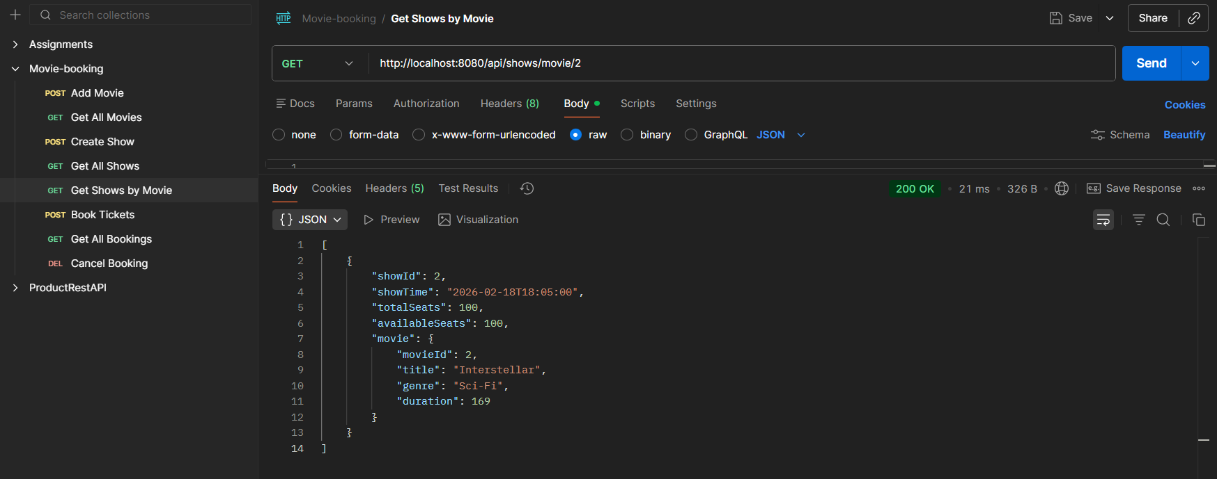

- API 6: Book Tickets
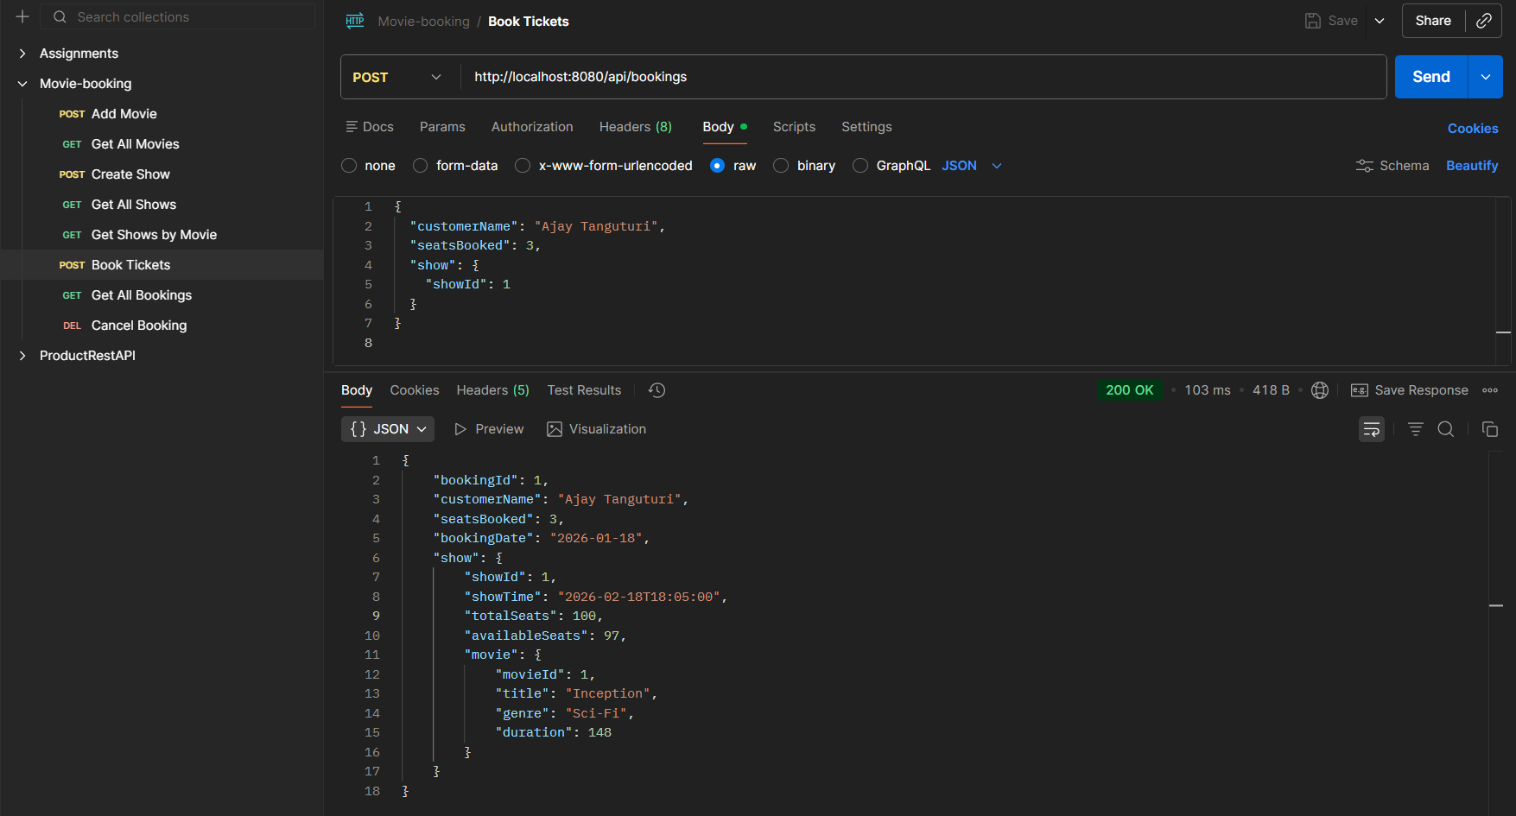
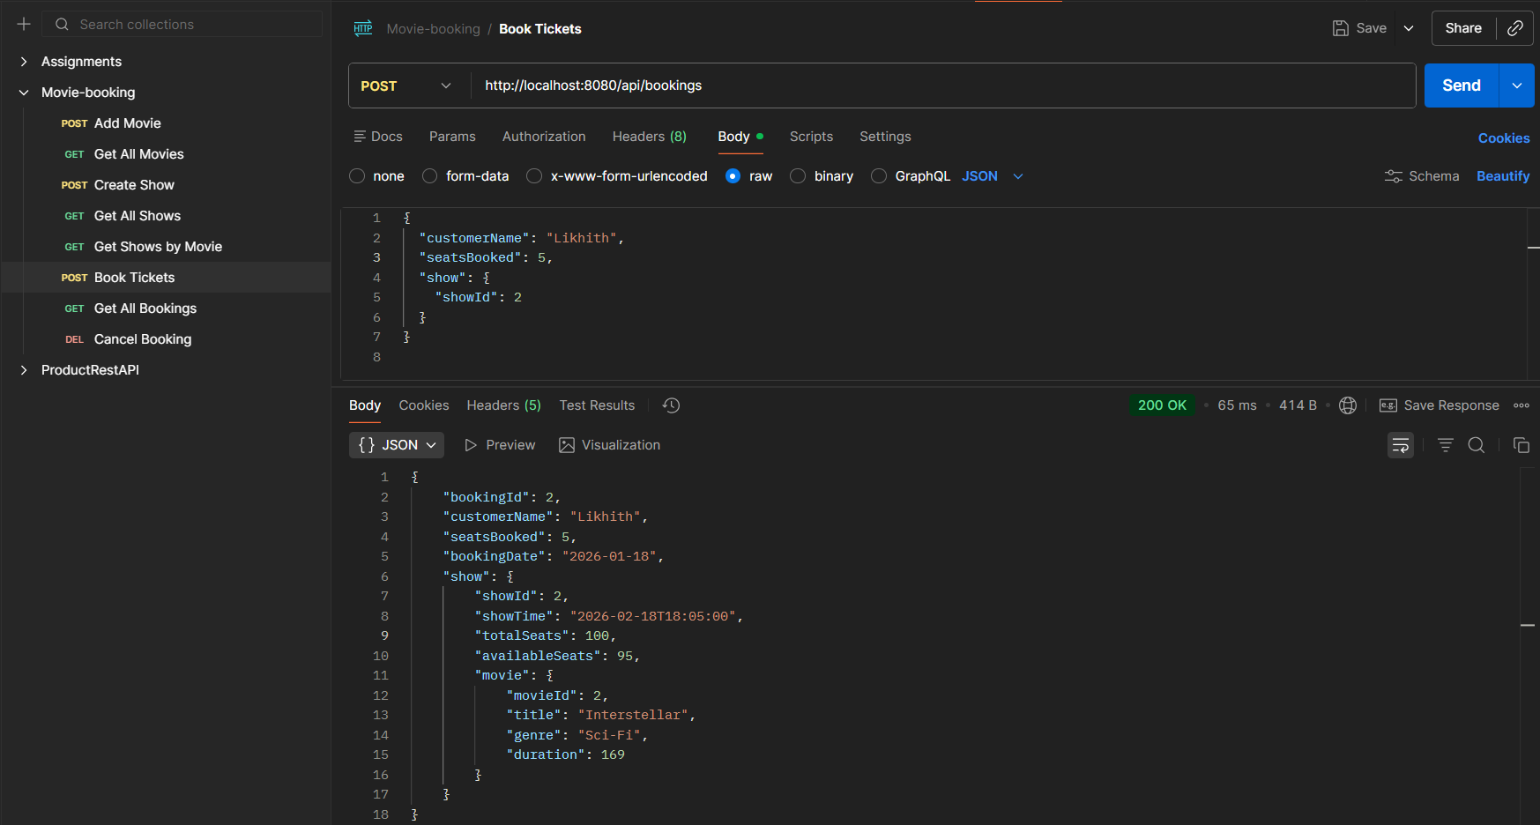

- API 7: Get All Bookings
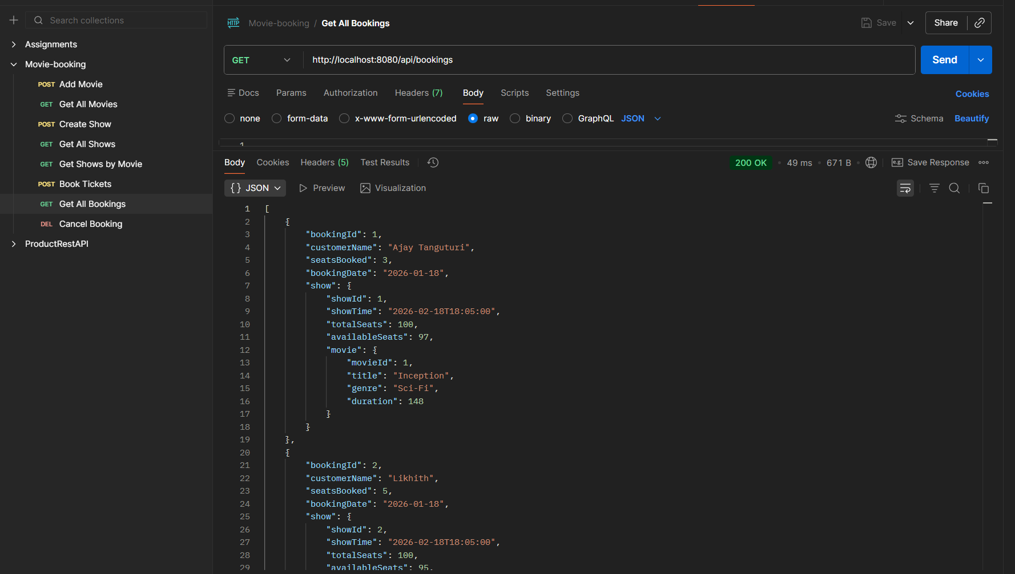
- API 8: Cancel Booking
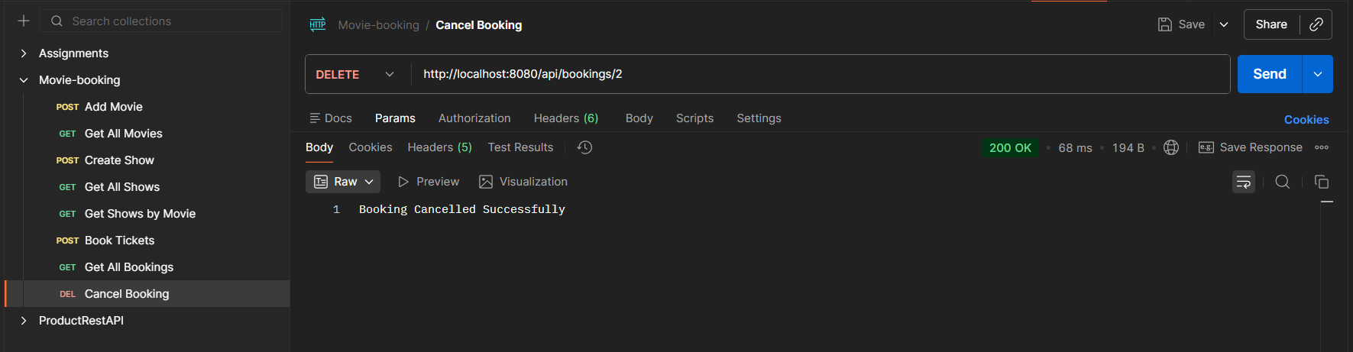
After cancelling the movie id 2 we have the movie data for movie id: 1
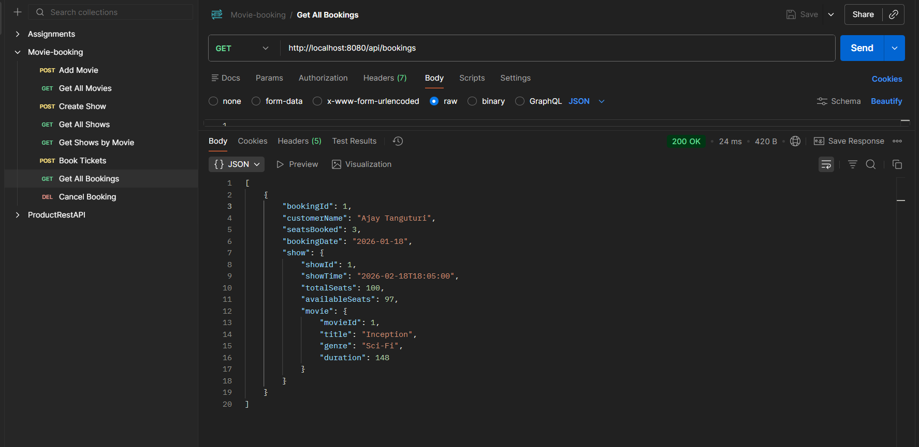
Conclusion:
The Simple Movie Booking project successfully demonstrates the development of a RESTful backend application using Spring Boot and MySQL. It implements core functionalities such as managing movies, scheduling shows, booking tickets, and cancelling bookings while enforcing essential business rules like seat availability and automatic booking date generation. This project provides a clear understanding of layered architecture, REST API design, and database integration, making it a strong foundation for real-world backend application development.

